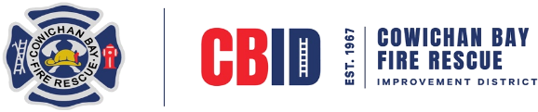

Cowichan Bay Improvement District
4461 Trans Canada Hwy,
Cowichan Bay, BC V0R 1N1

EMAIL cbid@cbvfr.com
WEBSITE cbid.cbvfr.com
PHONE 250.743.7111

Monthly Board of Trustees Meeting Agenda
April 17, 7:00 – 9:00 pm
- Call to Order / Declaration of Conflict of Interest
- Approval of the Agenda
Recommendation: To approve the Agenda as presented
Moved: Seconded:
- Adoption of the Minutes from March 20, 2024 Regular Board Meeting.
Recommendation: That the minutes of the Regular Board Meeting held March 20 2024 be adopted as circulated.
Moved: Seconded:
4. Business Arising from the Minutes
4.1 Strategic Plan
4.2 AGM
4.3 Website
4.4 Tablets
5. Standing Reports
5.1 Finance
5.1.1 Monthly Financial Report
5.1.2 Monthly Expenditures
Recommendation: That the Finance Report be received for information.
Moved: Seconded:
5.2 Fire Chief Report
5.2.1 Fire Department monthly report
Recommendation: That the Fire Department Report be received for information
5.3 Chairperson Report
5.4 Trustee Reports.
6. Correspondence
6.1 For Action – .
6.2 For Information
7. Committee / Project Reports
7.1 Fire Hall Construction project
8. New Business
8.1 Fire Smart Grant
8.2 Old to New Hall transition plan
9. Notice of Motion

10. Question Period
10.1 Anyone from the public wishing to ask a question on material presented at this meeting (must be a land owner within the Improvement District, state name, address of residence)
11. In Camera
12. Adjournment
Next Meeting: May 15th 7:00pm

Agenda Prepared by: Rhonda Smith Hodgkin, CBID Office Manager
Marsha Stanley Chair Board of Trustees

